23.66: a) 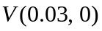=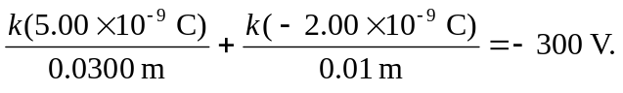
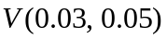=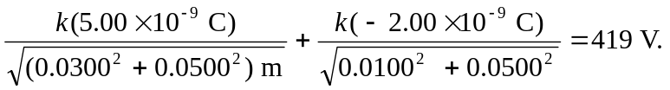
b) =
Note that the work done by the field is negative, since the charge is moved AGAINST the electric field.

